**Teacher Notes - Buying a Vehicle**

It is reasonable to assume that the majority of seventeen year olds would find it difficult to fund the purchase of a vehicle themselves. This programme looks at some of the costs, both fixed and variable, which the owner of a second hand vehicle is likely to incur. Although they may not need the information immediately it will help them in the future when they may be in a position to make a purchase.

Apart from the compulsory requirements before the driver puts the car on the road, i.e. driving licence, insurance, car tax, and MOT, there are also the unknown costs which depend to some extent on the condition of the vehicle purchased and the distances travelled. Repairs to older vehicles can be expensive, fuel costs can be high and the depreciation in the vehicle’s value must also be considered along with regular servicing. Altogether, owning a car or motorcycle represents a constant drain on income and can place motoring in the luxury category for a lot of people.

The PowerPoint presentation illustrates various methods of locating a suitable vehicle and it also covers methods of payment, such as cash or finance.

After completing this unit the students should:

• Know the legal requirements for learning to drive

• Manage their expectations and be able to evaluate their own potential towards vehicle ownership in relation to income and expenditure.

• Understand that it is not just how the car looks but the importance of the safety features – standard and enhanced.

• Have an understanding of the true costs of vehicle ownership

• Know the difference between ‘fixed’ costs, such as road tax and MOT and ‘variable’ costs, such as insurance (which can be beyond the means of many students)

• Appreciate the likelihood of ‘unforeseen’ expenses when running a vehicle, such as a breakdown and repairs.

This unit is aimed at a 35 -40 minute lesson. The teacher can use the task sheets as a follow up to the power point presentation as and when required. We have included a suggested time for each task, but this is purely a guideline.

The following resources are intended to help you deliver this Unit.

• Baseline evaluation (five minutes) (ANNEX A)

• Power point presentation/discussion (20 minutes)

• Task sheets (five minutes per task sheet)

• Post evaluation (five minutes) (ANNEX B)

**ANSWERS TO TASK SHEETS**

***The answers given below are correct as at November 2016, these prices are likely to change annually and you should consult www.nidirect.gov.uk for up to date costs.***

**Task Sheet 1**

**Buying a vehicle – Essential costs**

**Q1.** £115.00 for one year road tax based on a 2014 Renault Clio Hatchback 1.2.

You can also purchase 6 months road tax at a cost of £63.25, which will work out more expensive over the year.

*Vehicle tax rates for cars registered on or after 1 March 2001 are split into 13 bands depending on CO2 emissions. The amount you'll pay depends on which band your car is in. The lower a car’s emissions, the lower the vehicle tax payable on it.*

**Q2.** £30.50 is the cost for an MOT test; if the vehicle fails it will need to be retested at a cost of £18.50

**Q3. (a)** A Provisional Driving Licence costs £62.50

**(b)** Driving Theory Test costs £23.00

**(c)** Driving practical Test cost £45.50

Please note that £45.50 is the price for a test taken on a weekday, should you require a test date on a weekday evening or weekend this cost will rise to £62.50.

**Q4.** The total cost is £271.50 (again based on costs at July 2017)

**Q5.** Insurance - a separate module in this series of short programmes is available on insurance.

**Q6. A)** Answers may include seatbelts, airbags, adjustable seats, anti-lock braking system (ABS), good visibility.

**Q6. B)** Answers may include cruise control, lane-keeping technology, safety cage, traction control, parking sensors/cameras, gear shift indicator, daytime running lights, speed limitation devices

**Task Sheet 2**

Vehicle Documentation

Q1. Jane needs the following before she can drive off alone

Students should have the following numbers in the thought clouds:-

2 - Motor insurance

6 - Road tax

7 - Driving licence full

10 - MOT certificate

11 - Vehicle Registration Document

12 – Fuel

Q2. The jumbled letters will spell the following

1. Licence

2. Road Tax

3. MOT Certificate

4. Insurance

5. Age Seventeen

6. Normal vision

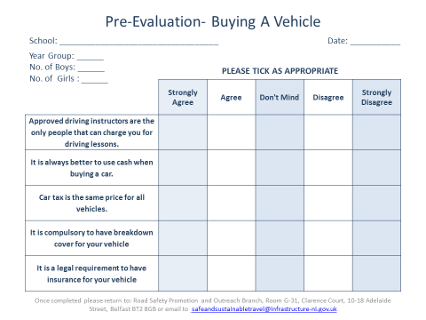

Annex A

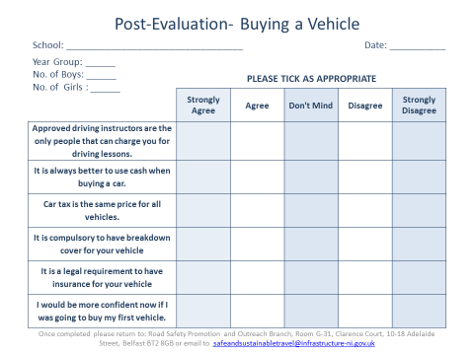

Annex B