**Taking Risks**

This unit is intended to introduce young people to important areas of road safety which will be of value to them throughout their lives. This unit is a self-contained resource covering the topic of ‘Taking Risks ‘ and how risk taking can lead to serious injury or death to pedestrians, passengers, drivers and cyclists.

The process of transforming inexperienced pedestrians, cyclists and motorists into responsible road users is a long and complex one that requires both training and education. This unit aims to make young people aware of ways to reduce the amount of risk to which they subject themselves to and how it impacts on their lives as road users.

* Know what is meant by risk and risk-taking.
* How to reduce the risk and identify risk-taking situations on the road.
* Understand the consequences of taking-risks.

This Unit is aimed at a 35 – 40 minute lesson. The teacher can use the task sheets as a follow up to the power point presentation as and when required. We have included a suggested time for each task, but this is purely a guideline.

The following resources are intended to help you to deliver this Unit:

* Baseline evaluation (5mins) (ANNEX A)
* Power point presentation/discussion (20 mins)
* Task sheets (5 mins per task sheet)
* Post evaluation (5 mins) (ANNEX B)

**ANSWERS TO TASKHEETS**

**Task Sheet 1**

|  |  |
| --- | --- |
| Crossing without looking | ✓ |
| Using a Zebra crossing |  |
| Crossing between parked cars | ✓ |
| Running across the road when a car is approaching at speed | ✓ |
| Crossing when the Pelican light is green for those crossing |  |
| Walking to face oncoming traffic on country roads |  |
| Dress in dark clothes when walking after dark. | ✓ |
| Wearing ear phones while crossing the road | ✓ |

**2. Risks the two pedestrians have taken inc:-**

These are possible answers derived from photograph. They are both crossing while the traffic is still moving. Not waiting on pavement until the traffic light is green for pedestrians. The man in orange appears to be looking down and not watching the traffic.

**3. How the two pedestrians could have reduced the risk inc:-**

Wait until the traffic has stopped;

Ensure that the light is green for pedestrians;

Pay attention while crossing.

**4. Possible answers from the students could be:-**

Fooling around and not paying attention

Not checking the road before crossing

Encourage you to take chances

**Task Sheet 2**

1. **Possible answers inc:-**

Mountaineering – risk of falling;

Deep see diving – risk of drowning;

Go- cart racing – risk of crashing.

1. **Risks that face cyclists inc:-**

Hit by a vehicle;

Pothole on road;

Crash resulting from poor brakes on bicycle;

Back draft caused by passing lorries, buses etc driving too close.

1. **Reduce risks by:-**

Properly maintaining your bicycle;

Wearing a cycle helmet;

Wearing proper clothing giving protection and making one more visible;

Being properly trained inc. knowing proper signals / lifesaver looks.

1. **The Highway Code advises cyclists not to...**

Cycle on footpath – unless cycle track provided;

Carry a passenger – unless adapted to carry one;

Hold on to moving vehicles;

Ride in a dangerous, careless or inconsiderate manner;

Ride while under the influence of alcohol or drugs;

Cross the stop line when traffic lights are

**Task Sheet 3**

**1. Situations where you must not overtake include:-**

You are not sure that the road ahead is clear – bends, road junctions, brow of a hill, hidden dip;

You don’t have a gap ahead of the road user you plan to overtake;

Vehicles are beginning to overtake you;

Where you would force another road user to swerve or slow down;

There is a solid double white line in the centre of the road or one solid white line in the middle of the road that is nearest to you.

**2. How do you overtake safely?**

Ensure the road is sufficiently clear ahead;

The road is ahead is straight – no hidden dips etc;

There is a gap in the traffic ahead for you to pull into;

Road markings permit overtaking;

Remember MSM – Mirror, Signal, and Manoeuvre;

**3.** **Other actions that are considered risk taking while driving inc:-**

Driving while under the influence of alcohol/drugs;

Using the mobile phone

Listening to loud music inc. using earphones;

Looking at passengers while chatting;

Holding hands with partner while driving;

Eating or lighting up a cigarette while driving;

**Task Sheet 4**

**Most at Risk - Road Users Killed & Seriously Injured 2011-2015:-**

|  |  |
| --- | --- |
| **Road User** | **Percentage Fatalities** |
| Driver | 43.22% |
| Pillion passenger | 0.63% |
| Vehicle passenger front | 11.99% |
| Vehicle passenger rear | 8.20% |
| Pedestrian | 20.82% |
| Motorcyclist | 11.67% |
| Pedal cyclist | 3.47% |

* Drivers and passengers account for the highest percentage of road fatalities and serious injuries (66.84%)
* Males aged 17–24 are most at risk and are 4 times more likely to be killed and seriously injured on our roads, followed by males aged 25-34 years old

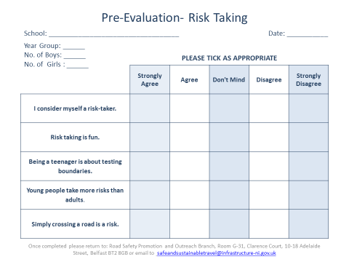

Annex A

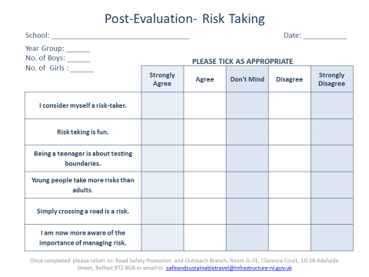

Annex B